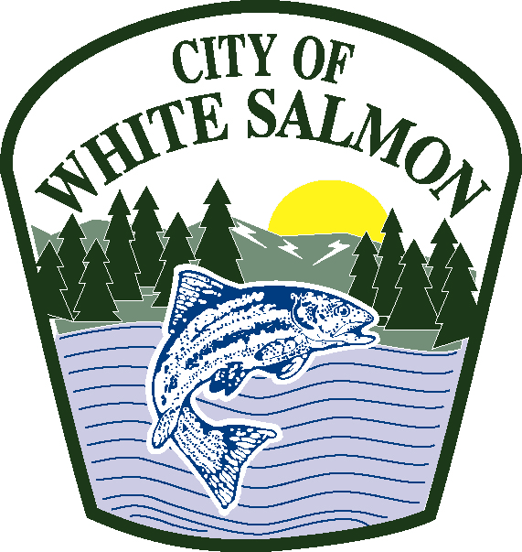

City of White Salmon
Office of City Hall

INTENT TO FILE APPLICATION FOR FEDERAL ASSISTANCE
The City of White Salmon intends to file an application for federal financial assistance with the U.S. Department of Agriculture, Rural Development, Rural Utilities service. The project includes improvements to the water distribution system. Comments will be taken at a public meeting on April 3, 2019 at 6:00 p.m. at White Salmon Fire Hall, 220 NE Church Avenue, White Salmon, WA 98672.

For additional information, contact Jan Brending at 509-493-1133 #205 or janb@ci.white-salmon.wa.us.

ORDINANCE ADOPTION – Ordinance 2019-03-1039, Amending 2019 BUDGET
The City of White Salmon City Council at its regularly scheduled meeting on March6, 2019 passed Ordinance 2019-03-1039, Amending the 2019 Budget. The full text of the ordinance will be mailed upon request. Please make your requests in person at City Hall, 100 N. Main, White Salmon, WA or in writing to P.O. Box 2139, White Salmon, WA 98672.

Jan Brending, Clerk Treasurer -- Posted March 28, 2019

